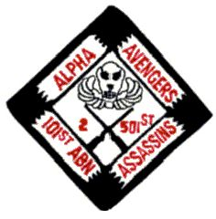
- 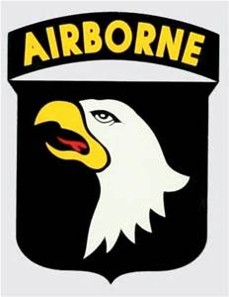
Alpha Avengers
Of Vietnam Association
Summer 2016 Newsletter

Newsletter

A Message from the President

Hello Avengers and Avengerettes,

I hope everyone made it home safely from the New Orleans reunion.

Wow is all I can say about the reunion. It was absolutely fantastic! Ken did a great job of planning for the reunion and all of that planning added to a successful meeting, reunion and tribute.

I think the WWII Museum was one of the highlights of the reunion. What a moving tribute to all the men and women that served in that war.

General Mitchell did an excellent job of presenting the Some Gave All award to Ed Bishop’s sister, Alicia Dellarpia, with a compassionate tribute. It was a very emotional for all of the attendees.
We can only hope and pray that one day his family and other MIA’s families get closure.

Also, I would like to say it is an honor and a privilege to serve as President of the association. I know I have big shoes to fill with the great job all of the past Presidents have done, but will do my very best.
 |  | Association Officers
 |  | JUNE 2016-JUNE 2018
 |  | www.alphaavengers.com
PRESIDENT | V.PRESIDENT | SECTRETARY | TREASURER | WEBMASTER
Jim (Millard) Sims | Ken Snyder | Linda Sims | Diane Manguilli | Barth Cunico
109 Englewood Dr | 823 Singing Trails Dr | 109 Englewood Dr | 14 Randall Dr | 740 Union St
Bardstown, KY 40004 | El Cajon, CA 92019 | Bardstown, KY 40004 | New Haven, CT 06473 | Marseilles, IL 61341
PH: 502-510-3200 | PH: 619-846-2683 | PH: 502-510-3200 | PH: 203-234-8849 | PH: 815-228-7616
misims76@yahoo.com | lemsjer1@cox.net | simsl@bardstown.com | claylady21@yahoocom | barth@bcunico.com

I would like to thank Ken Snyder for accepting the VP job and Diane Manguilli (Treasure) Barth Cunico (Web Master) and of course my wife, Linda for accepting the Secretary position.

Looking forward to our next reunion and would like to hear from all about a location for our next
meeting site. We hope to start vetting some recommendations soon.

Have a great summer and good health to all!

