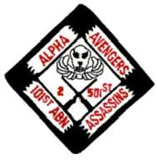
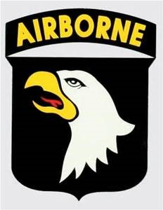

Alpha Avengers
Of Vietnam
Association
Spring 2017 Newsletter

A Message from the President

Hello Avengers and Avengerettes,

I hope everyone is doing well and excited about next year’s reunion! It will be difficult to top the fantastic New Orleans reunion but we are going to give it our best!

We have heard from several members about suggestions for locations and your comments and recommendations are so appreciated. Typically, we have tried to rotate the location to points of interest that are proximal to airports or transportation hubs.
However, the sight we have picked is a little further away from airports but it is within eight-hour drive of 40% of the population. Hopefully this will not inconvenience anyone too much.

We have not held any reunions in the northern part of the United States so we have chosen Gettysburg, Pennsylvania as our reunion site for 2018. The history and beauty of the area are incredible. Pat Runevitch, Paul Gochnour, my wife Linda and I spent three days there on a site visit and just loved everything about it. The dates for the reunion are June 4th through the 7th.

We have negotiated some pretty good rates at the Wyndham Hotel in Gettysburg for $124.00 a night. (These are normally $169-189 a night). They will honor these rates for the day before and the day after. We stayed there when we went on our site visit and they treated us fantastic. They have a campus of about 100 acres that has a microbrewery, a movie theater, and several restaurants. They have hosted numerous military reunions. There is a hop on hop off shuttle bus that you can access for $3.00 per day. They go to many locations in and around town. I encourage you to google Wyndham Gettysburg to look at the Hotel and all the amenities they offer.

Also, we have two tours set up with Wolf’s Bus Line. We were told by numerous people there that they are the best. They have luxury coaches and restrooms on board. You will have a choice of a two hour and a four-hour guided tour.

Both tours include a guide and the guide on the four-hour tour will be a retired Colonel and ex-Vietnam veteran. Included in the price is admission to the Gettysburg National Military Visitor Center to see a film, visit their Cyclorama and their Museum and a tour of the battlefield. (See attachment)
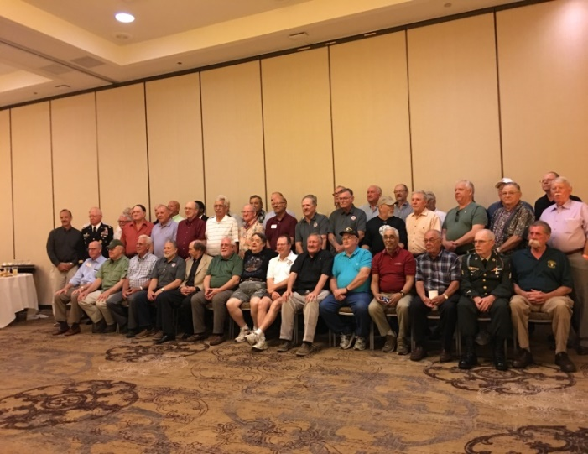
I would recommend watching the movie Gettysburg to get some history of how the battle played out.

I encourage each and every one to attend the reunion and to reach out to someone that has not attended our reunion in a while or has never attended. We want to keep the spirit and comrade of Alpha Co 2nd/501st alive and well.
If you have any questions please email me
At misims76@yahoo.com or call me at 502-510-3921
 |  | Association Officers
 |  | JUNE 2016-JUNE 2018
 |  | www.alphaavengers.com
PRESIDENT | V.PRESIDENT | SECTRETARY | TREASURER | WEBMASTER
Jim (Millard) Sims | Ken Snyder | Linda Sims | Diane Manguilli | Barth Cunico
109 Englewood Dr | 823 Singing Trails Dr | 109 Englewood Dr | 14 Randall Dr | 740 Union St
Bardstown, KY 40004 | El Cajon, CA 92019 | Bardstown, KY 40004 | New Haven, CT 06473 | Marseilles, IL 61341
PH: 502-510-3921 | PH: 619-846-2683 | PH: 502-510-3200 | PH: 203-234-8849 | PH: 815-228-7616
misims76@yahoo.com | Kensher1@cox.net | simsl@bardstown.com | claylady21@yahoocom | barth@bcunico.com

Proud to call you all my brothers.

--Jim (Millard) Sims
A Message from the Vice President

Alpha Avengers brothers I am looking forward to our next year reunion in Gettysburg. I hope all of you are doing well and excited about our next reunion as I am. Please encourage those who have not attended to do so. I’m looking forward to seeing all of you. May God bless and keep you till then.

--Ken Snyder

INFORMATION ABOUT GETTYSBURG

June 4-7, 2018
Download the free My Gettysburg App
www.DestinationGettysburg.com
ACCOMODATIONS:
Wyndham Hotel Gettysburg
Must register by May7th 2018
Reference: Alpha Avengers Association
717-339-0020
PLANNED GROUP TOURS
Wolf’s tours Tuesday June 5th (see attached)
OPTIONAL POINTS OF INTEREST:
Washington, DC 78 miles away
Hershey, PA 50 miles away (for the chocolate lovers)
New York City 200 miles away
Downtown Gettysburg
Outlet Mall
REGISTRATION:
June 4th-6th
BANQUET DINNER:
June 6th
There will be a surprise guest at the dinner!

SOME GAVE ALL AWARD:

The recipient is Tony Ward nominated by Guy Rudawski. Tony’s family will be present to accept the award. I have enclosed some information on how Tony died provided by Guy.

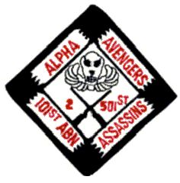REGISTRATION 2018 REUNION 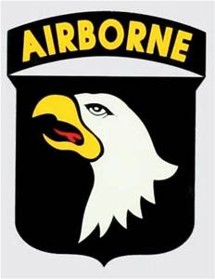
Member Name________________________
REUNION REGISTRATION
Number of people in your group____________Registration @$25 per person
Please choose one Entrée per person:
Wedge Salad
with Crumbled Blue Cheese, Bacon Bits, and Tomato
Served with Ranch Dressing
~Choice of (1) Entrée per person~
Sautéed Breast of Chicken
Served with Sauce Puttanesca, Goat Cheese Polenta, Wilted Baby Spinach, and Seasonal Vegetables
or
Grilled Flat Iron Steak
Served with Chimichurri Sauce, Whipped Potatoes with Applewood Smoked Bacon, Asparagus, and Baby Carrots
~Dessert~
Chocolate Mousse Cake
Coffee and Tea Service
Tour June 5, 2018 (see attachment from Wolf’s Bus Lines for description)
Please indicate if you wish to take the:
- Two-hour bus tour of battlefields: Cost $ ___ per person /Number in party ____
- Four-hour bus tour of battlefields: Cost $ ___ per person /Number in party____
- Museum film, cyclorama, museum, and tour included
Total Dues and Reunion Registration and Tour Fees $____________
____________________________________________________________________________
Please make checks payable to: Alpha Avengers

Attach and send registration to:
Treasurer
Diane Manguilli
14 Randall Dr
New Haven, CT 06473 PH:203-234-8849

claylady21@yahoo.com
